Test Case: tc002_SPX_Dev5_Crear_Requisicion_Spot_Con_FAD_Tipo_Cobro_CC
Step 1 - Enter username and password and click to button Enter : Credentials Entered
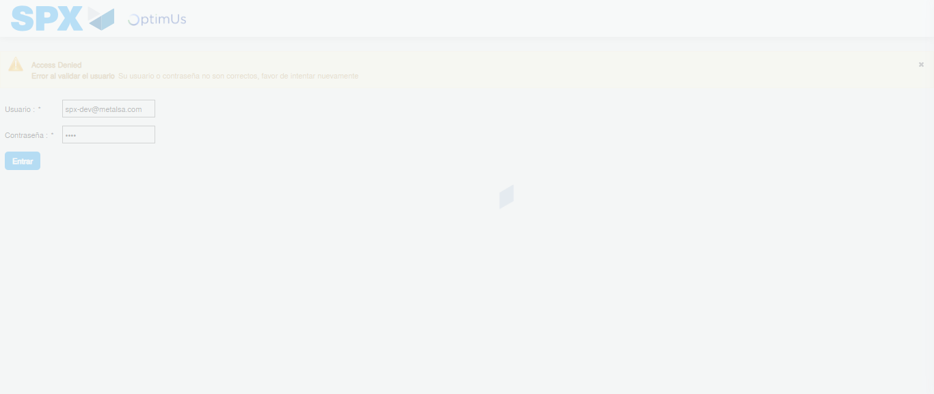Image file-name: QC_Testing-tc002_SPX_Dev5_Crear_Requisicion_Spot_Con_FAD_Tipo_Cobro_CC-1790169787001

Step 2 - Select to UEN and Access to Spot Buy Requisitions : UEN Correctly selected and Correct access
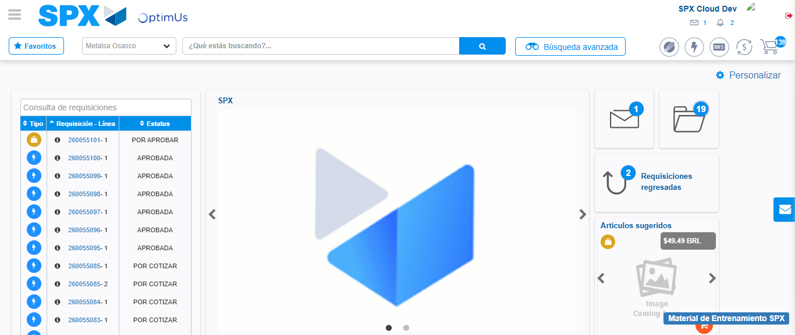Image file-name: QC_Testing-tc002_SPX_Dev5_Crear_Requisicion_Spot_Con_FAD_Tipo_Cobro_CC-1790169810671

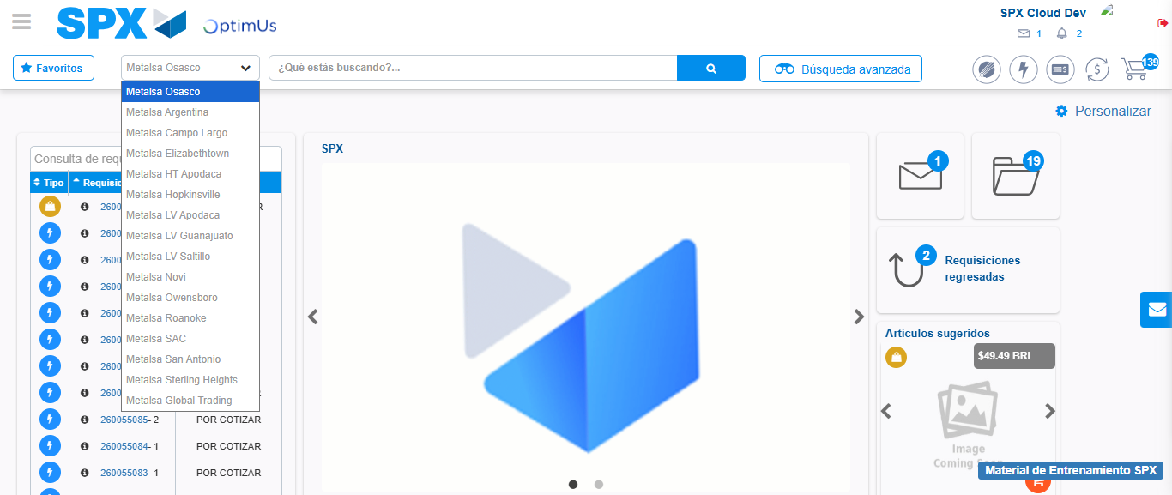Image file-name: QC_Testing-tc002_SPX_Dev5_Crear_Requisicion_Spot_Con_FAD_Tipo_Cobro_CC-1790169811387

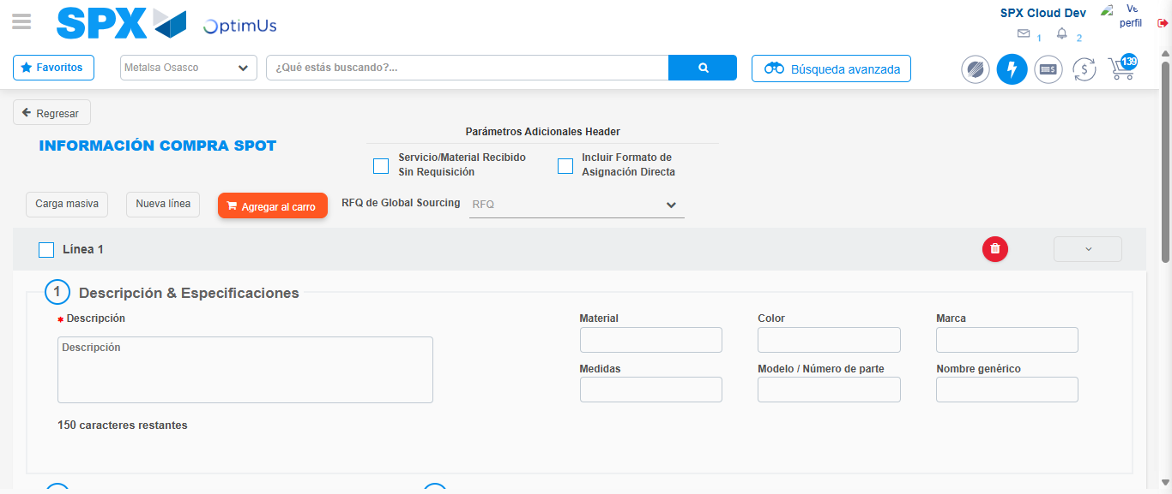Image file-name: QC_Testing-tc002_SPX_Dev5_Crear_Requisicion_Spot_Con_FAD_Tipo_Cobro_CC-1790169816147

Step 3 - Add FAD to Requisition: FAD Successfully Added
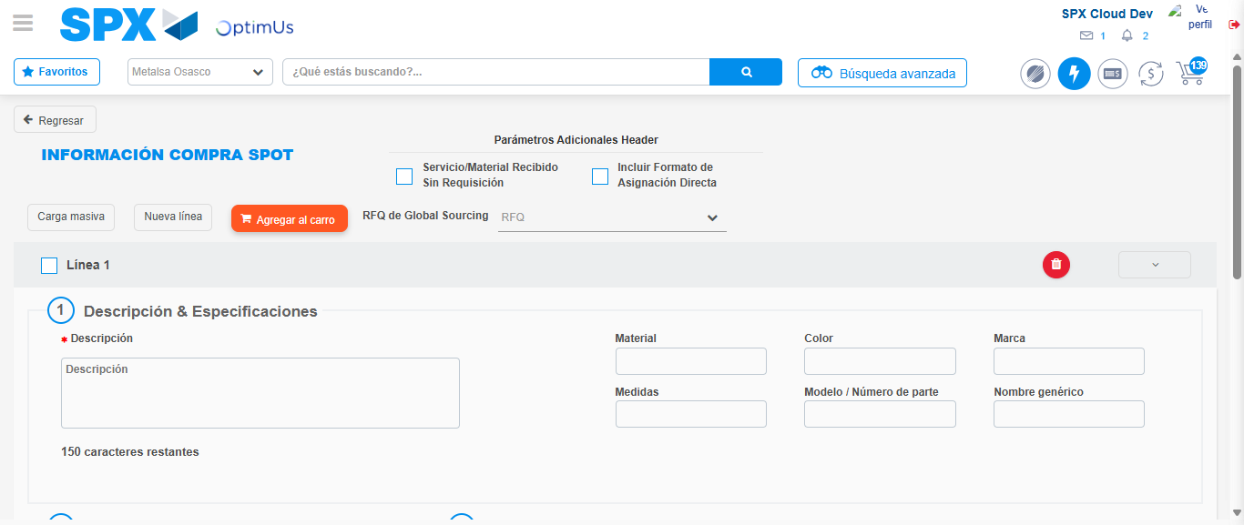Image file-name: QC_Testing-tc002_SPX_Dev5_Crear_Requisicion_Spot_Con_FAD_Tipo_Cobro_CC-1790169816504

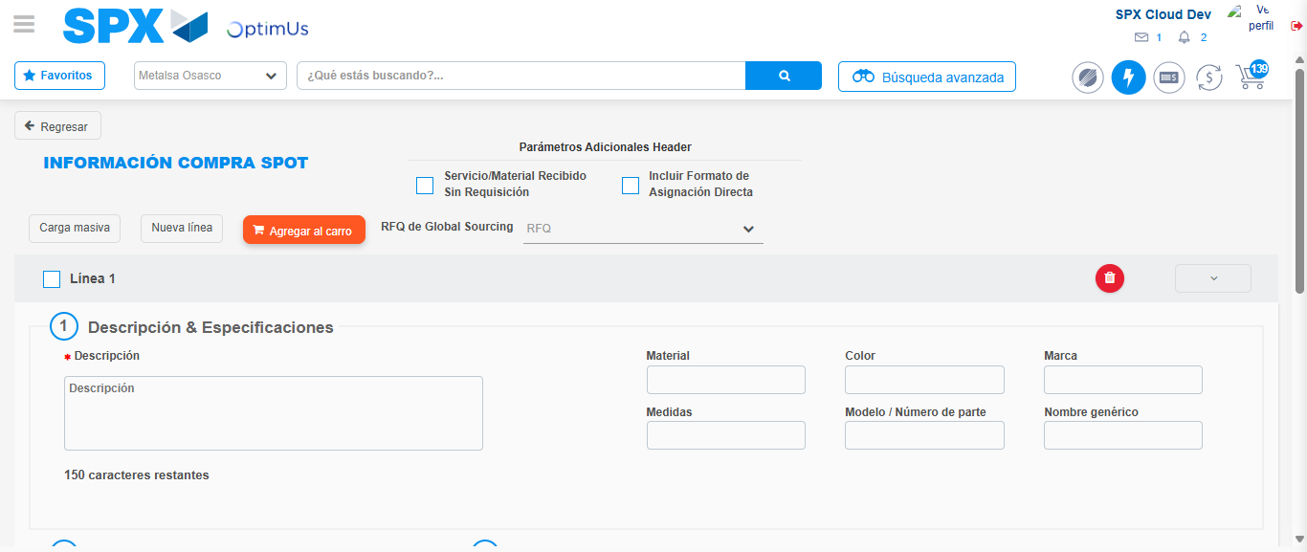Image file-name: QC_Testing-tc002_SPX_Dev5_Crear_Requisicion_Spot_Con_FAD_Tipo_Cobro_CC-1790169816779

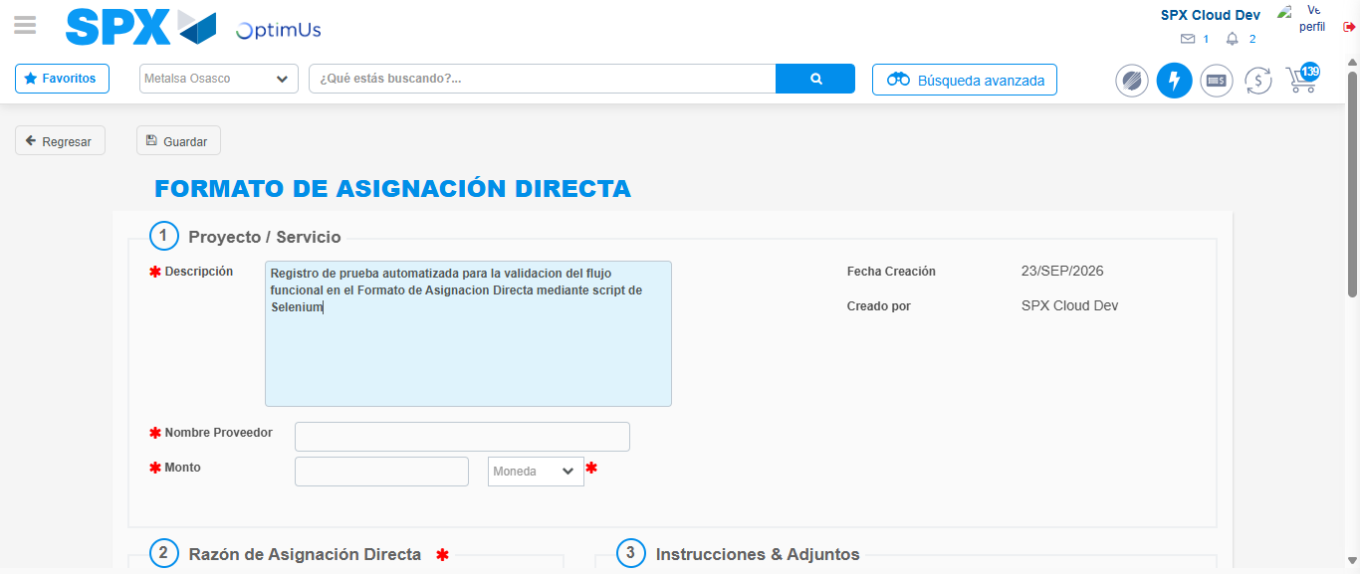Image file-name: QC_Testing-tc002_SPX_Dev5_Crear_Requisicion_Spot_Con_FAD_Tipo_Cobro_CC-1790169819777

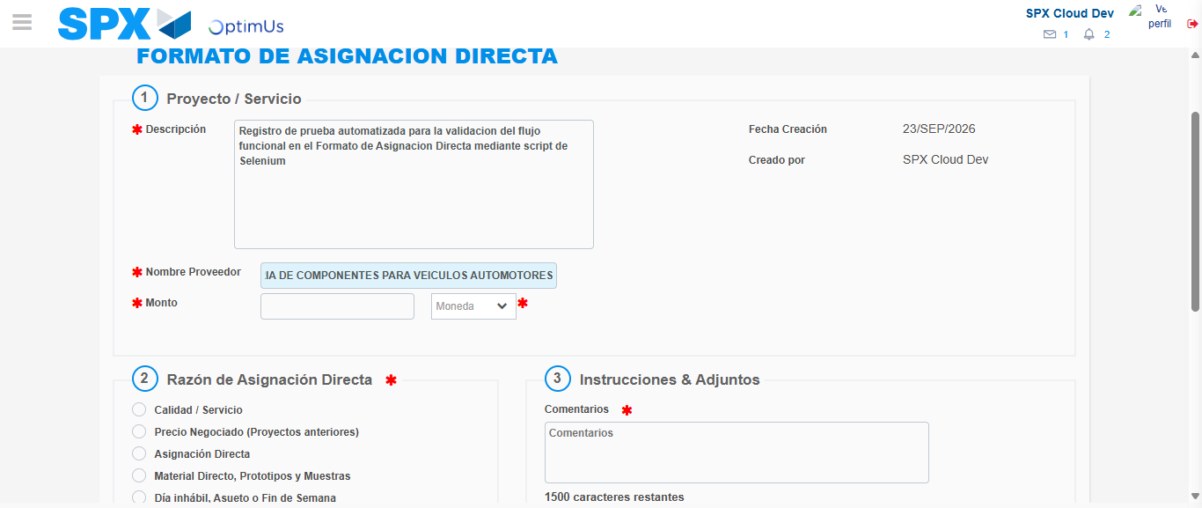Image file-name: QC_Testing-tc002_SPX_Dev5_Crear_Requisicion_Spot_Con_FAD_Tipo_Cobro_CC-1790169829654

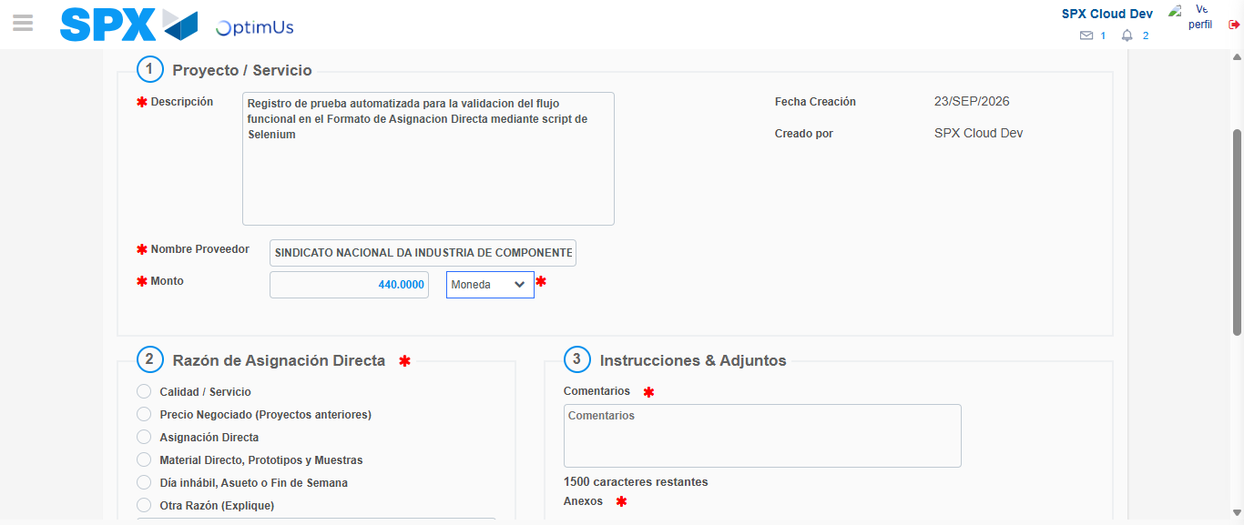Image file-name: QC_Testing-tc002_SPX_Dev5_Crear_Requisicion_Spot_Con_FAD_Tipo_Cobro_CC-1790169830167

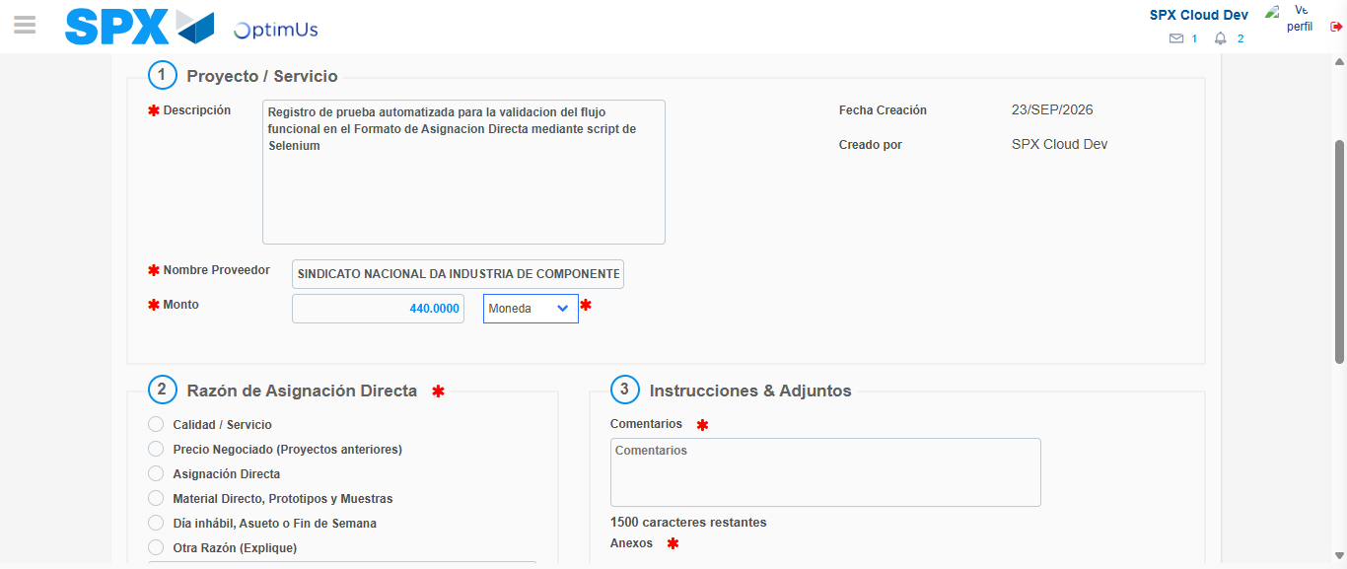Image file-name: QC_Testing-tc002_SPX_Dev5_Crear_Requisicion_Spot_Con_FAD_Tipo_Cobro_CC-1790169830431

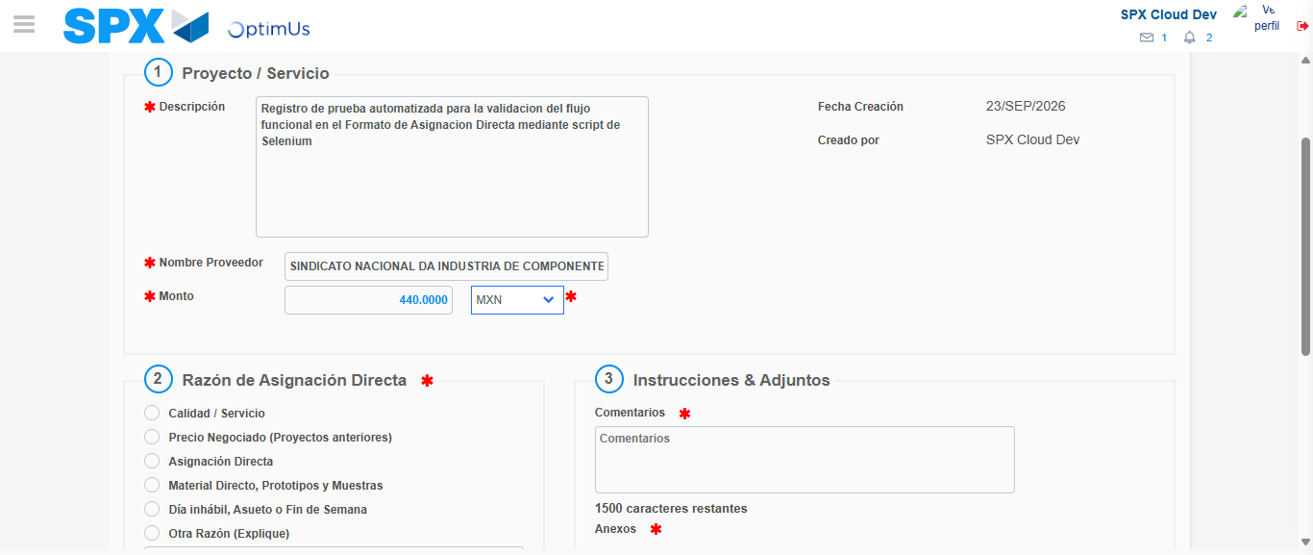Image file-name: QC_Testing-tc002_SPX_Dev5_Crear_Requisicion_Spot_Con_FAD_Tipo_Cobro_CC-1790169831147

Image file-name: QC_Testing-tc002_SPX_Dev5_Crear_Requisicion_Spot_Con_FAD_Tipo_Cobro_CC-1790169831380

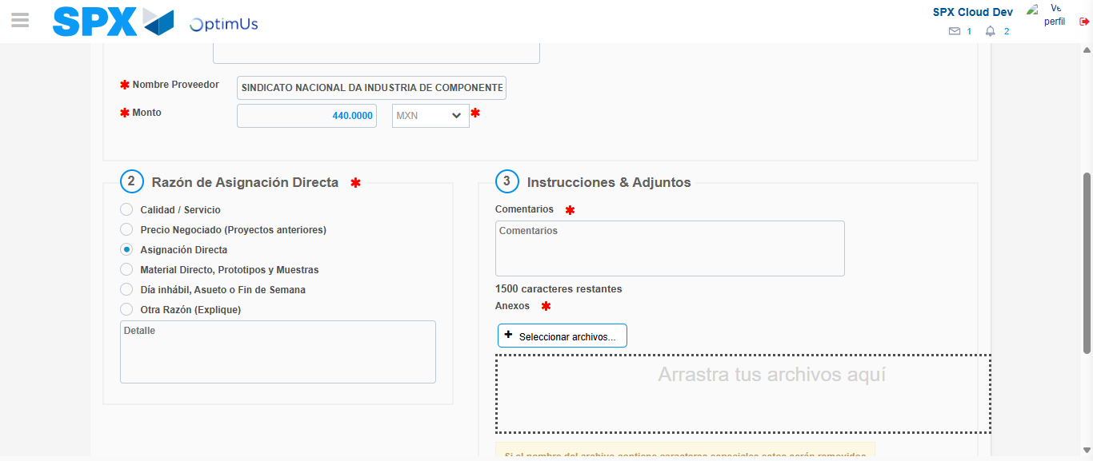Image file-name: QC_Testing-tc002_SPX_Dev5_Crear_Requisicion_Spot_Con_FAD_Tipo_Cobro_CC-1790169832233

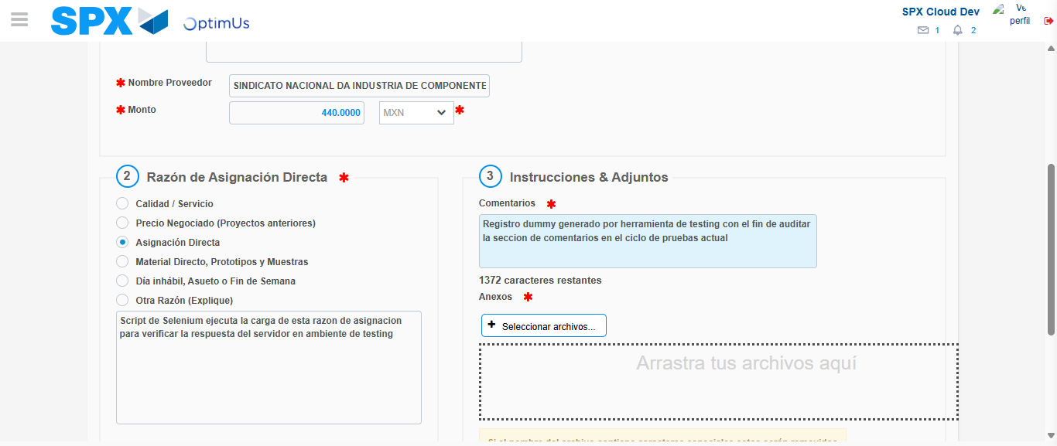Image file-name: QC_Testing-tc002_SPX_Dev5_Crear_Requisicion_Spot_Con_FAD_Tipo_Cobro_CC-1790169843418

Image file-name: QC_Testing-tc002_SPX_Dev5_Crear_Requisicion_Spot_Con_FAD_Tipo_Cobro_CC-1790169844391

Step 4 - Data Capture Spot Buy Requisition: Data captured correctly
Image file-name: QC_Testing-tc002_SPX_Dev5_Crear_Requisicion_Spot_Con_FAD_Tipo_Cobro_CC-1790169816504

Image file-name: QC_Testing-tc002_SPX_Dev5_Crear_Requisicion_Spot_Con_FAD_Tipo_Cobro_CC-1790169816779

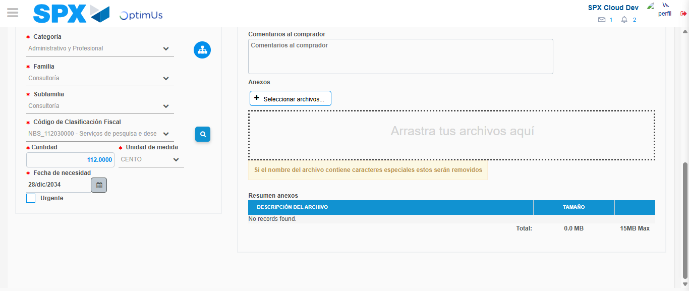Image file-name: QC_Testing-tc002_SPX_Dev5_Crear_Requisicion_Spot_Con_FAD_Tipo_Cobro_CC-1790169863689

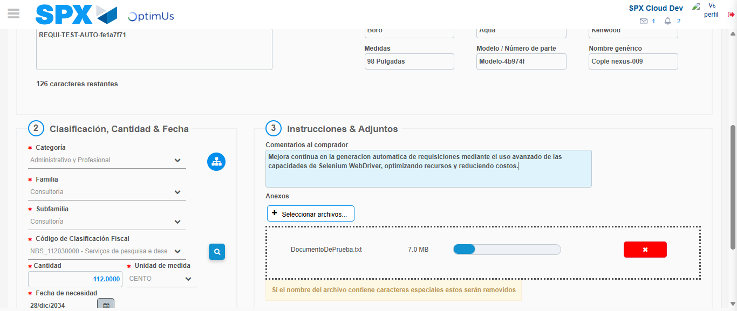Image file-name: QC_Testing-tc002_SPX_Dev5_Crear_Requisicion_Spot_Con_FAD_Tipo_Cobro_CC-1790169864578

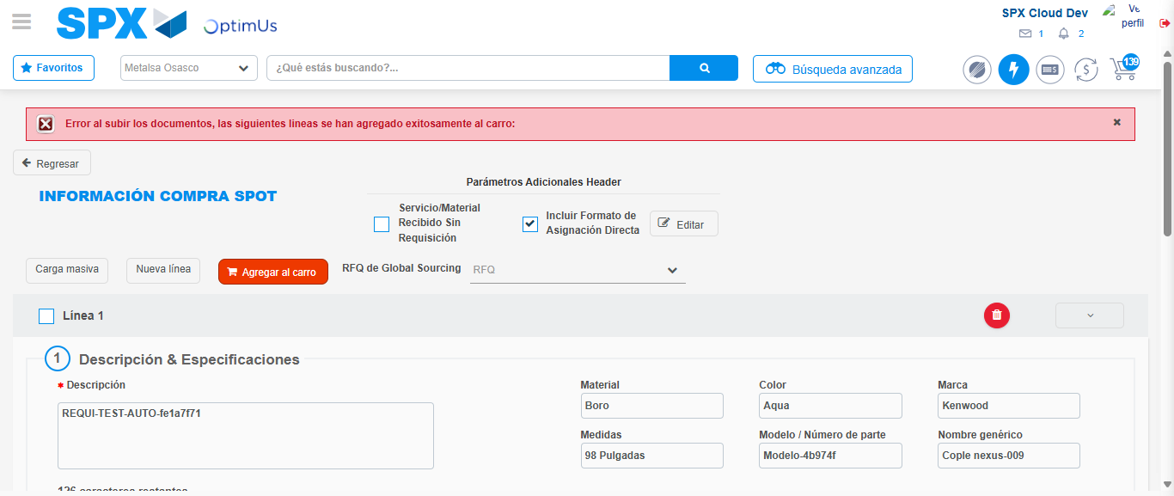Image file-name: QC_Testing-tc002_SPX_Dev5_Crear_Requisicion_Spot_Con_FAD_Tipo_Cobro_CC-1790169879021

Step 8 - Return to Main Page SPX : Return to Main Page SPX
Image file-name: QC_Testing-tc002_SPX_Dev5_Crear_Requisicion_Spot_Con_FAD_Tipo_Cobro_CC-1790169810671

Image file-name: QC_Testing-tc002_SPX_Dev5_Crear_Requisicion_Spot_Con_FAD_Tipo_Cobro_CC-1790169811387

Image file-name: QC_Testing-tc002_SPX_Dev5_Crear_Requisicion_Spot_Con_FAD_Tipo_Cobro_CC-1790169816147

Image file-name: QC_Testing-tc002_SPX_Dev5_Crear_Requisicion_Spot_Con_FAD_Tipo_Cobro_CC-1790169881286

Image file-name: QC_Testing-tc002_SPX_Dev5_Crear_Requisicion_Spot_Con_FAD_Tipo_Cobro_CC-1790169881450

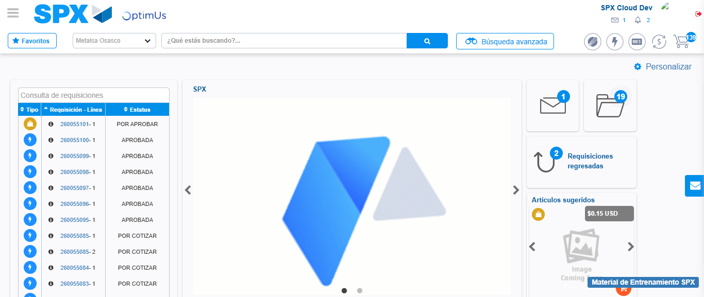Image file-name: QC_Testing-tc002_SPX_Dev5_Crear_Requisicion_Spot_Con_FAD_Tipo_Cobro_CC-1790169902732

Step 9 - Log Out : Log Out SPX
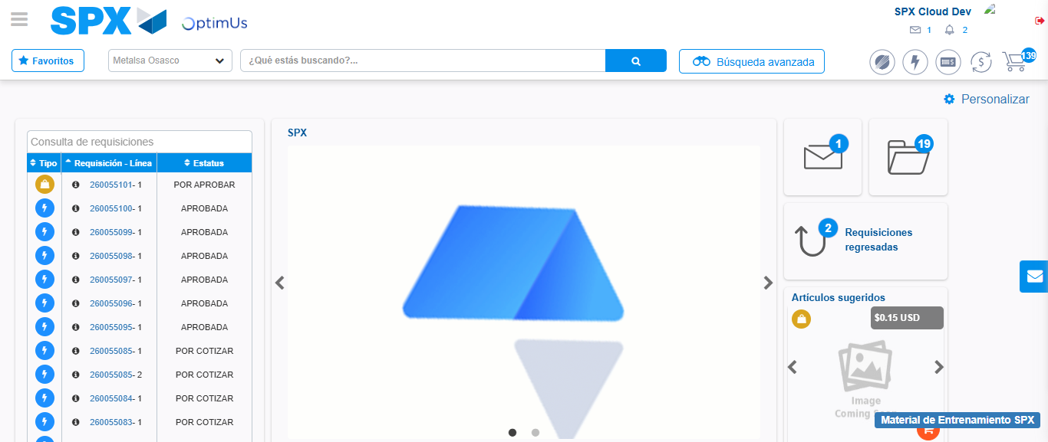Image file-name: QC_Testing-tc002_SPX_Dev5_Crear_Requisicion_Spot_Con_FAD_Tipo_Cobro_CC-1790169903101

